CS4163 - Advanced Networking, Virtualization and Cloud Computing
Practical ICA – (Assessment) 01
Task 03 - Security Policies and ACLs

01.ACL Configuration Script for Router 2 (R2)

ACL 103 – VLAN 10 (192.168.30.0/24):
access-list 103 permit ip 192.168.30.0 0.0.0.255 192.168.10.0 0.0.0.255
! Allow access to core VLAN 10 subnet

access-list 103 permit ip 192.168.30.0 0.0.0.255 192.168.30.0 0.0.0.255
! Allow same subnet communication

access-list 103 permit ip 192.168.30.0 0.0.0.255 192.168.50.0 0.0.0.255
! Allow communication with other VLAN 10 segment

access-list 103 deny ip 192.168.30.0 0.0.0.255 192.168.20.0 0.0.0.255
access-list 103 deny ip 192.168.30.0 0.0.0.255 192.168.40.0 0.0.0.255
access-list 103 deny ip 192.168.30.0 0.0.0.255 192.168.60.0 0.0.0.255
! Deny access to all VLAN 20 subnets

access-list 103 permit ip any any

ACL 104 – VLAN 20 (192.168.40.0/24):
access-list 104 permit ip 192.168.40.0 0.0.0.255 192.168.20.0 0.0.0.255
access-list 104 permit ip 192.168.40.0 0.0.0.255 192.168.40.0 0.0.0.255
access-list 104 permit ip 192.168.40.0 0.0.0.255 192.168.60.0 0.0.0.255
! Allow communication with VLAN 20 subnets

access-list 104 deny ip 192.168.40.0 0.0.0.255 192.168.10.0 0.0.0.255
access-list 104 deny ip 192.168.40.0 0.0.0.255 192.168.30.0 0.0.0.255
access-list 104 deny ip 192.168.40.0 0.0.0.255 192.168.50.0 0.0.0.255
! Deny access to VLAN 10

access-list 104 permit ip any any

ACL 105 – VLAN 10 (192.168.50.0/24)
access-list 105 permit ip 192.168.50.0 0.0.0.255 192.168.10.0 0.0.0.255
access-list 105 permit ip 192.168.50.0 0.0.0.255 192.168.30.0 0.0.0.255
access-list 105 permit ip 192.168.50.0 0.0.0.255 192.168.50.0 0.0.0.255
! Permit Management VLAN communication

access-list 105 deny ip 192.168.50.0 0.0.0.255 192.168.20.0 0.0.0.255
access-list 105 deny ip 192.168.50.0 0.0.0.255 192.168.40.0 0.0.0.255
access-list 105 deny ip 192.168.50.0 0.0.0.255 192.168.60.0 0.0.0.255
! Deny access to Guest VLANs

access-list 105 permit ip any any

Interface Configuration
interface GigabitEthernet0/1.10
ip access-group 103 in
description VLAN 10 - 192.168.30.0/24 (Management)

interface GigabitEthernet0/1.20
ip access-group 104 in
description VLAN 20 - 192.168.40.0/24 (Guest)

interface GigabitEthernet0/2.10
ip access-group 105 in
description VLAN 10 - 192.168.50.0/24 (Management)

interface GigabitEthernet0/2.20
ip access-group 106 in
description VLAN 20 - 192.168.60.0/24 (Guest)

ACL Configuration Script for Router 1 (R1)

ACL 101: For VLAN 10 (192.168.10.0/24)
access-list 101 permit ip 192.168.10.0 0.0.0.255 192.168.10.0 0.0.0.255
! Allow internal VLAN 10 traffic (e.g., PC1 ↔ PC3)

access-list 101 permit ip 192.168.10.0 0.0.0.255 192.168.30.0 0.0.0.255
! Allow communication from VLAN 10 to VLAN 10 subnet on R2 (192.168.30.0/24)

access-list 101 permit ip 192.168.10.0 0.0.0.255 192.168.50.0 0.0.0.255
! Allow communication from VLAN 10 to VLAN 10 subnet on R2 (192.168.50.0/24)

access-list 101 deny ip 192.168.10.0 0.0.0.255 192.168.20.0 0.0.0.255
! Deny traffic from VLAN 10 to VLAN 20 (192.168.20.0/24)

access-list 101 deny ip 192.168.10.0 0.0.0.255 192.168.40.0 0.0.0.255
! Deny traffic from VLAN 10 to VLAN 20 subnet on R2 (192.168.40.0/24)

access-list 101 deny ip 192.168.10.0 0.0.0.255 192.168.60.0 0.0.0.255
! Deny traffic from VLAN 10 to VLAN 20 subnet on R2 (192.168.60.0/24)

access-list 101 permit ip any any
! Permit all other traffic (e.g., OSPF, Internet routing)

ACL 102: For VLAN 20 (192.168.20.0/24)
access-list 102 permit ip 192.168.20.0 0.0.0.255 192.168.20.0 0.0.0.255
! Allow internal VLAN 20 traffic (e.g., PC2 ↔ PC4)

access-list 102 permit ip 192.168.20.0 0.0.0.255 192.168.40.0 0.0.0.255
! Allow communication from VLAN 20 to VLAN 20 subnet on R2 (192.168.40.0/24)

access-list 102 permit ip 192.168.20.0 0.0.0.255 192.168.60.0 0.0.0.255
! Allow communication from VLAN 20 to VLAN 20 subnet on R2 (192.168.60.0/24)

access-list 102 deny ip 192.168.20.0 0.0.0.255 192.168.10.0 0.0.0.255
! Deny traffic from VLAN 20 to VLAN 10 (192.168.10.0/24)

access-list 102 deny ip 192.168.20.0 0.0.0.255 192.168.30.0 0.0.0.255
! Deny traffic from VLAN 20 to VLAN 10 subnet on R2 (192.168.30.0/24)

access-list 102 deny ip 192.168.20.0 0.0.0.255 192.168.50.0 0.0.0.255
! Deny traffic from VLAN 20 to VLAN 10 subnet on R2 (192.168.50.0/24)

access-list 102 permit ip any any
! Permit all other traffic (e.g., OSPF, Internet routing)

Interface Configuration
interface GigabitEthernet0/2.10
ip access-group 101 in
description Applies ACL 101 to VLAN 10 (192.168.10.0/24) - inbound

interface GigabitEthernet0/2.20
ip access-group 102 in
description Applies ACL 102 to VLAN 20 (192.168.20.0/24) - inbound

Verification and Screenshots

• Intra-VLAN Traffic (VLAN 10):
- Test: Ping from PC5 (192.168.30.10, VLAN 10) to PC7 (192.168.50.10, VLAN 10).
- Result: Success (matches ACL 103, line 30).
- Screenshot:
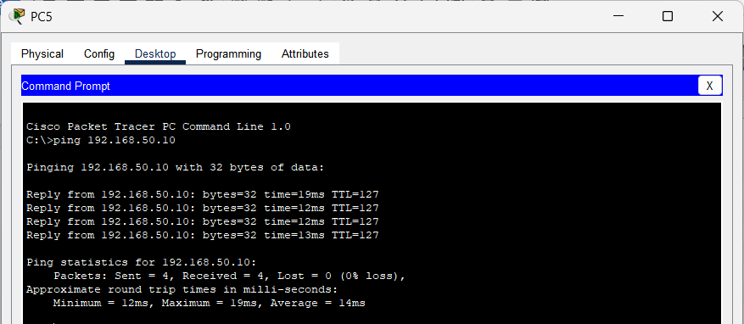
.

• Intra-VLAN Traffic (VLAN 20):
- Test: Ping from PC6 (192.168.40.10, VLAN 20) to PC8 (192.168.60.10, VLAN 20).
- Result: Success (matches ACL 104, line 30).
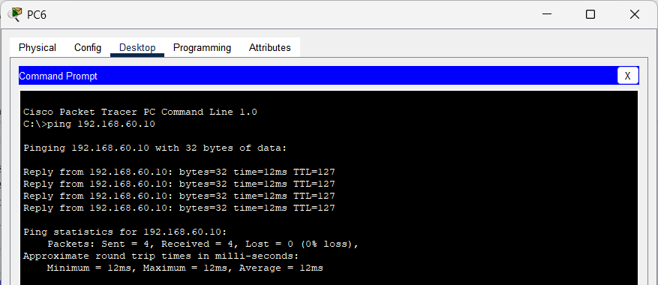
- Screenshot:

• Inter-VLAN Traffic (VLAN 10 to VLAN 20):
- Test: Ping from PC5 (192.168.30.10, VLAN 10) to PC6 (192.168.40.10, VLAN 20).
- Result: Fail (matches ACL 103, line 50).
- Screenshot:
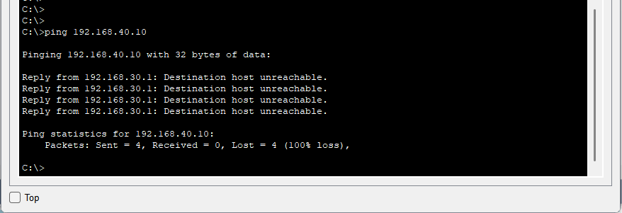

• Inter-VLAN Traffic (VLAN 20 to VLAN 10):
- Test: Ping from PC6 (192.168.40.10, VLAN 20) to PC7 (192.168.50.10, VLAN 10).
- Result: Fail (matches ACL 104, line 60).
- Screenshot:
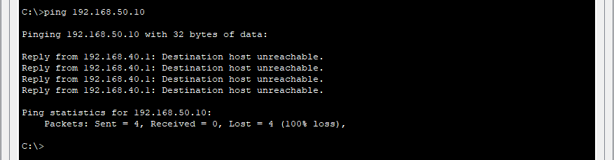

• Intra-Subnet Traffic (VLAN 10):
- Test: Ping from PC1 (192.168.10.10, VLAN 10) to PC3 (192.168.10.11, VLAN 10).
- Result: Success (matches ACL 101, line 10).
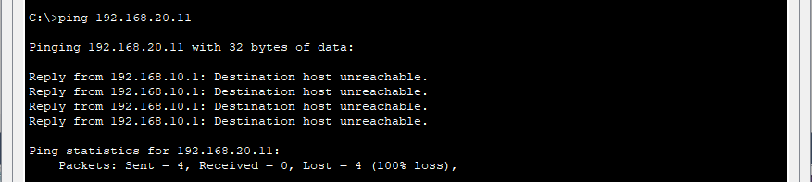
- Screenshot:

• Intra-VLAN Traffic (VLAN 10):
- Test: Ping from PC1 (192.168.10.10, VLAN 10) to PC5 (192.168.30.10, VLAN 10).
- Result: Success (matches ACL 101, line 20).
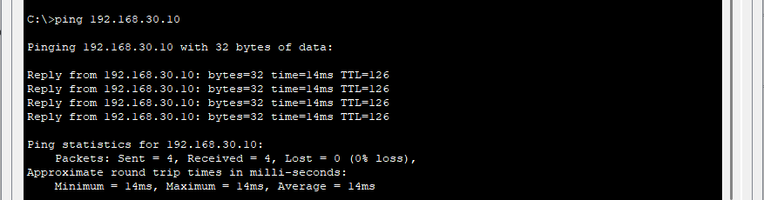
- Screenshot:

• Intra-Subnet Traffic (VLAN 20):
- Test: Ping from PC2 (192.168.20.10, VLAN 20) to PC4 (192.168.10.11, VLAN 20).
- Result: Fail (matches ACL 102, line 10).
- Screenshot:
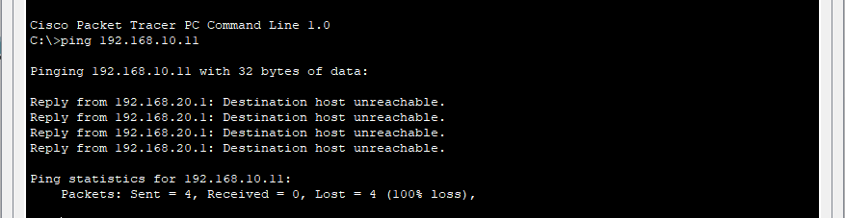

• Inter-VLAN Traffic (VLAN 10 to VLAN 20):
- Test: Ping from PC1 (192.168.10.10, VLAN 10) to PC2 (192.168.20.10, VLAN 20).
- Expected Result: Fail (matches ACL 101, line 40).
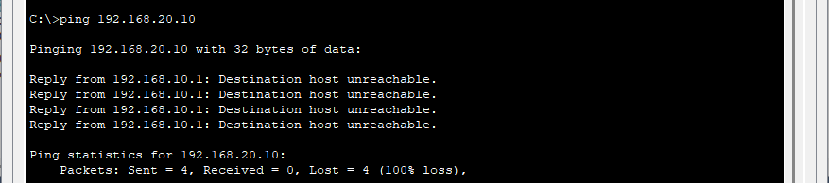
- Screenshot:

